September 19, 2023, File 10100-20/PPOS

City of Nanaimo Mayor and Council

mayor.council@nanaimo.ca

Dear Mayor and Council:

The Grasslands Conservation Council of BC (GCC) is a provincial non profit dedicated to the conservation of our grasslands that cover less than 1% of the province and have very high ecological and social values that will likely become even more important with climate change.

The GCC is very concerned about the proposed development of the Harewood Plains. Grasslands and open meadow environments are extremely rare in this part of BC and the Harewood Plains represent one of very few areas on Vancouver Island with this set of values.

The Harewood Plains is noted for the diversity of plant species. The site is home to a mixture of critically imperilled ecological communities that includes open Garry Oak woodlands (Garry Oak / California Brome and Garry Oak / Oceanspray) and vernal seeps (Tiny Mousetails / Montias spp. / Macoun’s Meadowfoam) (GOERT, 2011). The areas of greatest conservation importance are the open, seasonally wet meadows found in the north and east of the site. A combination of thin soils over bedrock and a slow release of winter-accumulated rainwater provides the physical conditions for the survival of these plant communities and species, some of which are found in few other places in Canada.

The BC Conservation Data Centre (CDC) has records for five species at risk on the site, some dating back many years. In recent years, another nine species at risk have been added to this list through iNaturalist users. The most famous of these species is Bird’s-foot Lotus (Hosackia pinnata, prev. Lotus pinnatus), Nanaimo’s official flower. It is known from only six sites in Canada, all of them near Nanaimo. This species, like many others of Harewood Plains, depends on the site’s unique hydrology and rock formations.

The GCC sincerely hopes that the City of Nanaimo will look closely at the ecological values of the Harewood Plains before allowing housing development that will lead to the permanent loss of this plant community. If you would like to discuss these concerns further please contact our Executive Director, Mike Dedels, P.Ag. at [mike@bcgrasslands.org](mailto:mike@bcgrasslands.org).

Yours in conservation

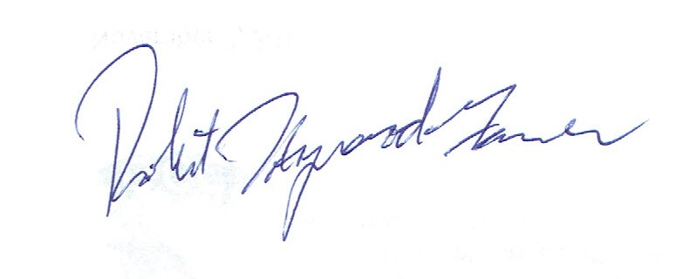

Bob Haywood-Farmer

Chair, Grasslands Conservation Council of BC

cc: Lisa-Marie Barron, MP, [lisamarie.barron@parl.gc.ca](mailto:lisamarie.barron@parl.gc.ca)  
cc: Doug Routley, MLA, [douglas.routley.MLA@leg.bc.ca](mailto:douglas.routley.MLA@leg.bc.ca)  
cc: NALT Media contact, treeisland6@gmail.com